**CIND 110 – Assignment 1 – Part II**

**Section DN0 - Student 501241365**

1.

SELECT name, continent , IndepYear , Region

FROM worlddb.country

WHERE Region = "Caribbean";

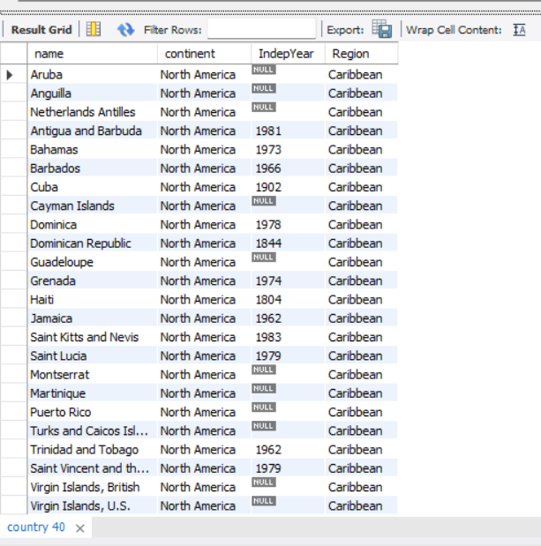

2.

SELECT Code , Name , Population , Language , IsOfficial

FROM worlddb.country JOIN worlddb.countrylanguage ON country.Code = countrylanguage.CountryCode

WHERE IsOfficial = "T"

ORDER BY Population DESC LIMIT 10;

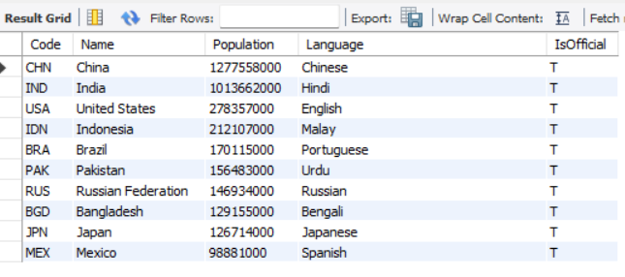

3.

SELECT Code , Name , Continent , IndepYear , Language , IsOfficial

FROM worlddb.country JOIN worlddb.countrylanguage ON country.Code = countrylanguage.CountryCode

WHERE IsOfficial = "T" AND Continent in ("North America" , "South America") AND IndepYear IS NOT NULL;

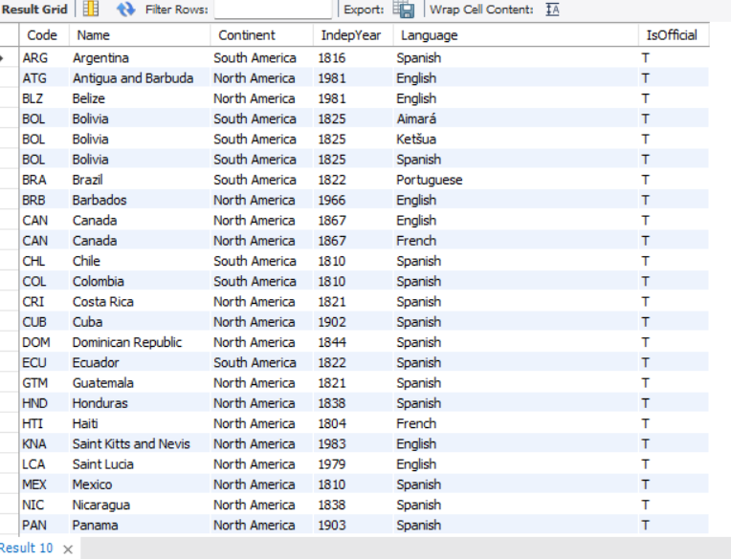

4.

SELECT country.Name

FROM worlddb.country JOIN worlddb.city ON country.Name = city.Name;

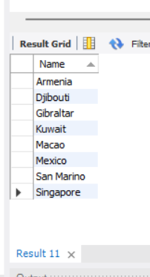

5.

SELECT Continent , COUNT( DISTINCT country.Name) AS "Number of Countries", COUNT( DISTINCT countrylanguage.Language) AS "Number of Languages Spoken"

FROM worlddb.country JOIN worlddb.countrylanguage ON country.Code = countrylanguage.CountryCode

GROUP BY Continent;

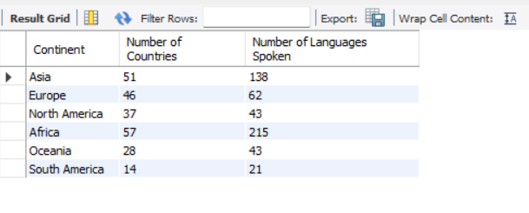

6.

SELECT Name , COUNT(DISTINCT countrylanguage.Language) AS "Number of Languages"

FROM worlddb.country JOIN worlddb.countrylanguage ON country.Code = countrylanguage.CountryCode

GROUP BY Name

HAVING COUNT(DISTINCT Language) > 10;

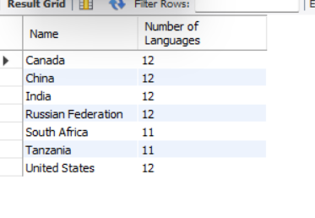

7.

SELECT Country.Name , GovernmentForm , HeadOfState

FROM worlddb.country

JOIN

(SELECT Name , COUNT(DISTINCT countrylanguage.Language) AS "Number of Languages"

FROM worlddb.country JOIN worlddb.countrylanguage ON country.Code = countrylanguage.CountryCode

GROUP BY Name

HAVING COUNT(DISTINCT Language) > 10

) AS VirtualTable

ON VirtualTable.Name = Country.Name;

